Time Setting Question for: SD4HD, SD4HW & RSD4HD, RSD4HW

1. Setting time directly:
2. Log in Menu by default password: 6666

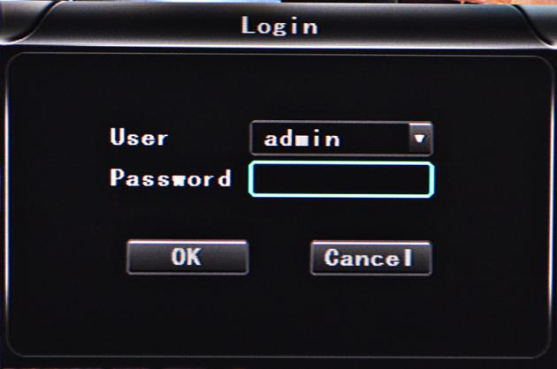

Noted: If you log in by password:1234, you just can see the setting but cannot change.

1. Come into “Base” setting and check the time and click “OK” to be Blue:

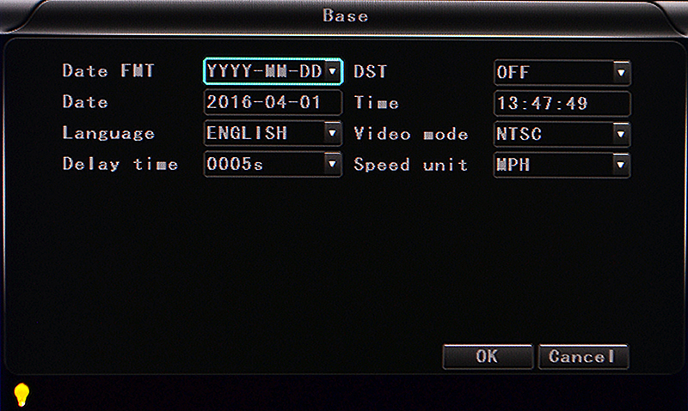

1. Use delete button on remote control to delete old setting and input new time:

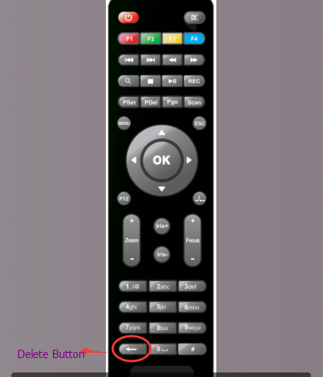

1. After setting, please restart MDVRs
2. GPS auto adjust time:
3. GPS antenna connects with MDVR and GPS works
4. Come in “GPS” setting and settle time district in the “GPS timing”. For example; UTC-5, Eastern standard time, you just need to choose UTC-5 in the GPS timing and restart MDVR, it will adjust the time automatically.

